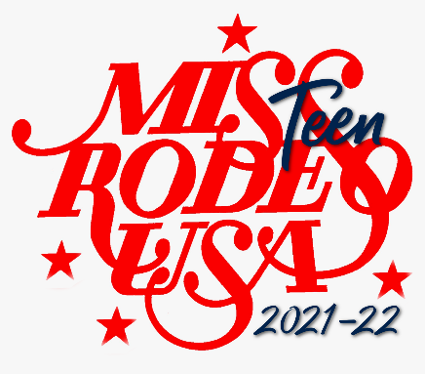
Miss Teen Rodeo USA Pageant 2021-22
Contestant Application

Name: _________________________________________________________________________
Age: _____________________ DOB: _______________________________________________
Address: _______________________________________________________________________
City, State, Zip: __________________________________________________________________
Phone: (_____)___________________ Email: _________________________________________

Sizing Chart
Shirt Size _________________ Jeans Size ________________ Boot Size _______________
Hat Size _________________ Jacket Size _____________________

Why do you want to be Miss Teen Rodeo USA? (Limit 200 words)
_______________________________________________________________________________________________________________________________________________________________________________________________________________________________________________________________________________________________________________________________________________________________________________________________________________________________________________________________________________________________________________________________________________________________________________________________________________________________________________

If you were chosen Miss Teen Rodeo USA, what would be your speaking platform?
(Please provide a TITLE for your Platform)
______________________________________________________________________________________________________________________________________________________________________________________________________________________________________________________________________________________________________________________________________________________________________________________________________________________________________________________________________________________________________________________________________________________

What are your career goals?
_______________________________________________________________________________________________________________________________________________________________________________________________________________________________________________________________________________________________________________________________________________________________________________________________________________________________________________________________________________________________________________________________________________________________________________________________________________________________________________

What awards/honors have you received?
_______________________________________________________________________________________________________________________________________________________________________________________________________________________________________________________________________________________________________________________________________________________________________________________________________________________________________________________________________________________________________________________________________________________________________________________________________________________________________________

What are your hobbies/activities/interests?
______________________________________________________________________________________________________________________________________________________________________________________________________________________________________________________________________________________________________________________________________________________________________________________________________________________________________________________________________________________________________________________________________________________

What contributions do you believe a rodeo queen can make to benefit the sport of rodeo and rodeo sponsors?
_______________________________________________________________________________________________________________________________________________________________________________________________________________________________________________________________________________________________________________________________________________________________________________________________________________________________________________________________________________________________________________________________________________________________________________________________________________________________________________

What horse/rodeo titles, championships or awards have you received?
_______________________________________________________________________________________________________________________________________________________________________________________________________________________________________________________________________________________________________________________________________________________________________________________________________________________________________________________________________________________________________________________________________________________________________________________________________________________________________________

Provide a brief biography: (Limit 200 words) Please write it in the third person.
_______________________________________________________________________________________________________________________________________________________________________________________________________________________________________________________________________________________________________________________________________________________________________________________________________________________________________________________________________________________________________________________________________________________________________________________________________________________________________________

