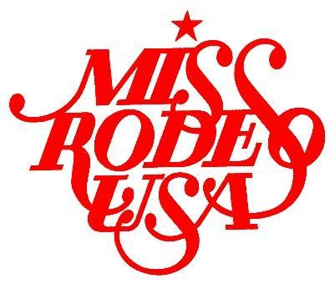

MISS RODEO USA 2024
CONTESTANT APPLICATION

NAME:
TITLE:
AGE:
DOB:
ADDRESS:
PHONE:
EMAIL:

WHY DO YOU WANT TO BE MISS RODEO USA? (Limit 200 words)
IF YOU WERE CHOSEN MISS RODEO USA, WHAT WOULD BE YOUR SPEAKING PLATFORM? (Limit 200 words) Please provide a TITLE for your platform.
WHAT IS YOUR EDUCATIONAL BACKGROUND?
WHAT ARE YOUR CAREER GOALS?
WHAT AWARDS/HONORS HAVE YOU RECEIVED?
WHAT ARE YOUR HOBBIES/ACTIVITIES/INTERESTS?
WHEN AND WHERE DID YOU BECOME INTERESTED IN RODEO?
WHAT CONTRIBUTIONS DO YOU BELIEVE A RODEO QUEEN CAN MAKE TO BENEFIT THE SPORT OF RODEO AND RODEO SPONSORS?
WHAT OTHER TITLES AND/OR RODEO TITLES HAVE YOU HELD?
WHAT IS YOUR EXPERIENCE WITH HORSES?
PROVIDE A BRIEF BIOGRAPHY: (Limit 200 words)
Must be written in THIRD person.
PLEASE GIVE ANY ADDITIONAL INFORMATION THAT YOU CARE TO GIVE THE JUDGES ON A SEPARATE SHEET OF PAPER. (signature required on page 7)

Please submit your application in the original Word document format.
Do not submit file as a PDF. Thank you!

Please acknowledge the following statement:
As a contestant of the Miss Rodeo USA Pageant, I understand that my application information will be provided to the judges UNEDITED by the Miss Rodeo USA Association, including but not limited to leaving grammatical errors, typos or formatting issues. However, the Miss Rodeo USA Association reserves the right to correct such issues for the purpose of advertising only (ie: the website, program, social media, etc.) The original document is the one that the judges will receive.

Please Initial: __________ Date: _____________

