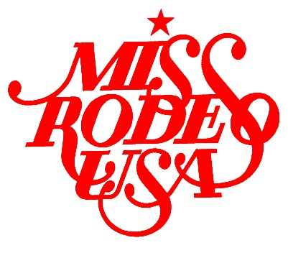

MISS RODEO USA 2019
CONTESTANT APPLICATION

NAME:
TITLE:
AGE:
DOB:
ADDRESS:
PHONE:
EMAIL:

WHY DO YOU WANT TO BE MISS RODEO USA? (Limit 250 words)
IF YOU WERE CHOSEN MISS RODEO USA, WHAT WOULD BE YOUR SPEAKING PLATFORM? (Limit 250 words)
WHAT IS YOUR EDUCATION BACKGROUND?
WHAT ARE YOUR CAREER GOALS?
WHAT AWARDS/HONORS HAVE YOU RECEIVED?
WHAT ARE YOUR HOBBIES/ACTIVITIES/INTERESTS?
WHEN AND WHERE DID YOU BECOME INTERESTED IN RODEO?
WHAT CONTRIBUTIONS DO YOU BELIEVE A RODEO QUEEN CAN MAKE TO BENEFIT THE SPORT OF RODEO AND RODEO SPONSORS?

WHAT OTHER TITLES AND/OR RODEO TITLES HAVE YOU HELD?
WHAT IS YOUR EXPERIENCE WITH HORSES?
PROVIDE A BRIEF BIOGRAPHY: (Limit 250 words)
Suggestion from the MRUSA Association: Please write in the third person
PLEASE GIVE ANY ADDITIONAL INFORMATION THAT YOU CARE TO GIVE THE JUDGES ON A SEPARATE SHEET OF PAPER.
Please submit your application in the original Word document format.
Do not submit file as a PDF. Thank you!

