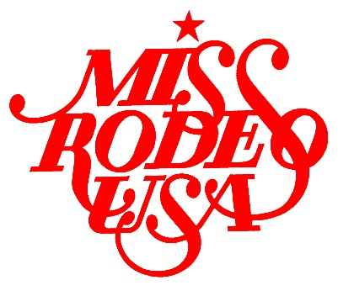
MISS RODEO USA 2017
CONTESTANT APPLICATION

NAME:
TITLE:
AGE:
DOB:
ADDRESS:
PHONE:
EMAIL:

WHY DO YOU WANT TO BE MISS RODEO USA?
IF YOU WERE CHOSEN MISS RODEO USA, WHAT WOULD BE YOUR SPEAKING PLATFORM?

WHAT IS YOUR EDUCATION BACKGROUND?
WHAT ARE YOUR CAREER GOALS?

WHAT AWARDS/HONORS HAVE YOU RECIEVED?
WHAT ARE YOUR HOBBIES/ACTIVITIES/INTERESTS?

WHEN AND WHERE DID YOU BECOME INTERESTED IN RODEO?

WHAT CONTRIBUTIONS DO YOU BELIEVE A RODEO QUEEN CAN MAKE TO BENEFIT THE SPORT OF RODEO AND RODEO SPONSORS?

WHAT OTHER TITLES AND/OR RODEO TITLES HAVE YOU HELD?

WHAT IS YOUR EXPERIENCE WITH HORSES?

PROVIDE A BRIEF (NO MORE THAN 200 WORD) BIOGRAPHY:

PLEASE GIVE ANY ADDITIONAL INFORMATION WHICH YOU CARE TO GIVE ON A SEPARATE SHEET OF PAPER. THE MISS RODEO USA JUDGES WILL HAVE ACCESS TO YOUR APPLICATION AND PICTURES

